3331 Assignment 3

Zaid Albirawi  
250626065

1. Construct a deterministic Turing machine $M$ that decides the language $$L=\left\{ω∈{\left\{a,b\right\}}^{*}|ω ends in a\right\}. \\ M$$ 
     
    starts with the initial configuration $\left(s, \underline{□}ω\right)$ and halts with the configuration $\left(q,\underline{□}ω^{'} \right)$, for the appropriate $q∈\left\{y, n\right\}.$
   1. Describe $M$ in details using the directed graph whose edges are labelled by transitions (such as the one in Example 17.2, p. 368 of textbook).  
        
      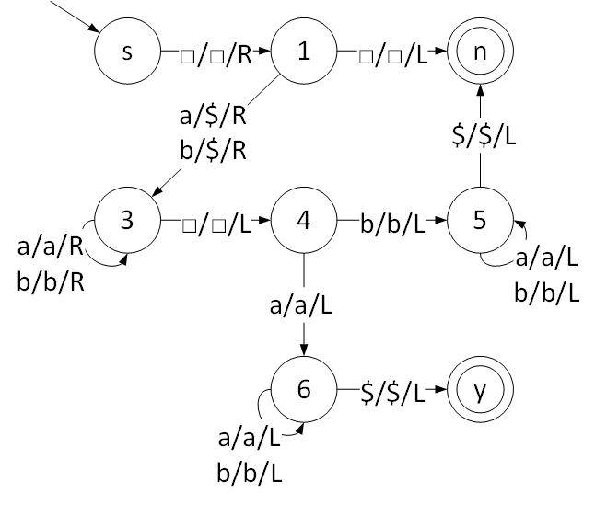
   2. Describe $M$ using the macro language (such as the one in Example 17.8, p. 376-377 of textbook).  
        
      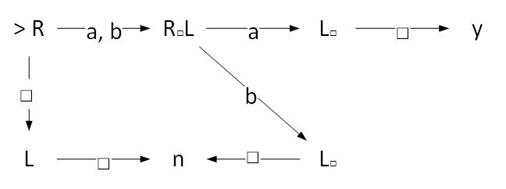
2. The universal Turing machine $U$, on input $<M, ω>$, simulates the work of the Turing machine $M$ on input $ω$. Explain what $U$ does on input $<U, <U, <M, ω>>>$.  
     
   First, to differentiate between the different universal machines we rewrite the input to $<U_{1}, <U_{2}, <M, ω>>>$. The universal Turing machine will simulate the work of the Turing machine $U_{1}$ on the input $< U_{2}, <M, ω>>$. While the machine $U_{2}$ from that input will also simulate the work of machine $M$ on the input $ω$. Discussing this in further detail, since a universal Turing machines input must be in the following format, $<M, ω>$, we denote the input of the universal machine to be $<M^{''}, ω^{''}>$. This input is equal to $<U_{1}, <U_{2}, <M, ω>>>$. Furthermore, we do the same thing for the universal machine ${ U}_{1}$, let the input of $U_{1}$ be $<M^{'}, ω^{'}>$ which is equal to $<U_{2}, <M, ω>>$. Hence, this is what that operations would look like, $$<U,<U_{1}, <U_{2}, <M, ω>>>> = <U, <M^{''}, ω^{''}>> \\ <U_{1}, <U_{2}, <M, ω>>> = <U_{1}, <M^{'}, ω^{'}>> \\ <U_{2}, <M, ω>>$$
3. Describe in clear English a Turing machine that semidecides the language $$L=\left\{<M>|M accepts at least two strings\right\}.$$ 
     
     
   Let the Turing machine $M$ run the dovetailing algorithm to enumerate all $ω∈Σ^{*}$ lexicographically. Run the machine until two strings are found. If two strings are found, halt and go to accepting state. Else keep enumerating strings.
4. Prove that the set $D$ of decidable languages is closed under union and concatenation. (Clear English description of the necessary Turing machines is sufficient.)  
     
   **Closure under Union:** Let $M_{1}$ and $M_{2}$ be Turing machines that accept the decidable languages $L_{1}$ and $L_{2}$ respectively. Also, let $M$ be a Turing machine that simulates the work of $M_{1}$ and $M_{2}.$ Therefore, $M$ will be able to decide ${ω∈L}_{1}∪L_{2}$ since both language are decidable. The idea behind this is for the machines $M$ to put the $M_{1}$ and $M_{2}$ tapes on its tape and work on them simultaneously, if either of the tapes reach a halting state, then halt and accept.   
     
   **Closure under Concatenation:** For this proof we have a string that is a concatenation of two languages, $L_{1}$ and $L_{2}$. The problem there is that we don’t know which part of the string belongs to which language. Therefore, we will need to a universal Turning machine $U$ that will simulate the work of the machines $M_{1}$ and $M_{2}$ that accept the languages $L_{1}$ and $L_{2}$ respectively. The idea is that we split $ω$ into the prefix ${x∈L}_{1}$ and postfix ${y∈L}_{2}$, $ω=xy$. What we then need to do is $<U, <M_{1}, x>>$, on all the prefixes of $ω$ until it accepts, if there does not exists a prefix that halts on accepting, then reject. If the prefix $x$ is accepted by $U$ then $<U, <M_{2}, y>>$, if $U$ accepts, then accept, else, reject and try the next prefix, if you run out of prefixes, reject. Since both languages are decidable, both the $M_{1}$ and $M_{2}$ machines will have to either accept or reject, which implies that machine $U$ will have to either accept or reject.